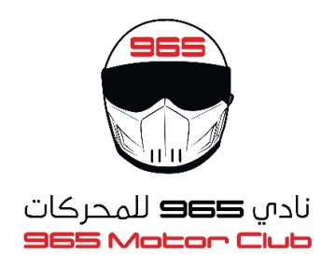
965 MOTOR CLUB
KUWAIT SUPERBIKE CHAMPIONSHIP
2022/2023

ROUND 1

TIMETABLE
23/12/2022
TIME | DURATION | ACTIVITY
08:30 - 10:00 | 1hr30 min. | Registration & scrutineering
10:15 - 10:30 | 15 min. | Riders Briefing – All Categories
10:45 - 11:05 | 20 min. | Free Practice – 600 cc
11:15 - 11:35 | 20 min. | Free Practice – 1000 cc
11:45 - 12:15 | 30 min. | Friday Prayer
12:30 - 12:45 | 15 min. | Qualifying – 600 cc
13:00 - 13:15 | 15 min. | Qualifying – 1000 cc
14:00 | 12 Laps | Race – 600 cc
15:00 | 12 Laps | Race – 1000 cc
16:30 |  | Prize Giving

